**Exam No. : 2449,4388**

**GUJARAT ARTS & SCIENCE COLLEGE**

****

**B. Sc. Computer Science [S. F.]**

**Semester VI**

**Year: 2019-2020**

**PROJECT REPORT**

**On**

**E-CLASSROOM**

**By: Lata viral,**

**Vhora yasin**

**GUJARAT ARTS & SCIENCE COLLEGE**

****

**CERTIFICATE**

**Uni.Exam No.: 2449,4388**

This is to certify that project report submitted by **Lata Viral & Vhora Mohammad Yasin** entitled “**E-Classroom**” of the B. Sc. Computer Science [S. F.] Semester VI in the academic year 2019-20 has satisfactory fulfilled all the requirements of in-house project at Gujarat Arts & Science College.

**Internal Examiner External Examiner Head of the Department**

**ACKNOWLEDGEMENT**

* It is our pleasure to acknowledge the contribution and assistance of a few individuals to this effort. We acknowledge here our debt to those who have contributed significantly to this project.
* We owe this moment of satisfaction with the deep sense of the gratitude to our project leader **Asst.Prof.Mrs.Unnati Patel** for this project and her interest guidance and constant supervision at any stage of work has been the greatest help for us in bringing out this work in the present shape.
* We are very thankful to **Asst.Prof.Ms.Anisha Gajjar**, **Asst.Prof.Mrs.Binal Patel** & **Asst.Prof.Ms.Jui Upadhyay** for motivating us and fostering a feeling of belongings towards our all masters. Their helpful solutions and comments enriches by their experience for the betterment of the project.
* We sincerely acknowledge that without their support this project would not have been feasible. Our thanks to all staff members of my B.Sc. Computer Science [S.F].
* Finally, we would like to thank our Course Coordinator **Dr. R.M.JADAV** and everyone who directly or indirectly helped us in the project.

**INDEX**

|  |  |  |  |  |
| --- | --- | --- | --- | --- |
| Sr. No. | Content | | | Page No. |
| 1 | Problem Definition | | | 5 |
| 2 | Software Requirement Specification | | | 6 |
| 2.1 | Current System & Its Drawbacks | | 6 |
| 2.2 | Proposed System & Its Features | | 7 |
| 2.3 | Software Specification | | 9 |
| 2.4 | Hardware Specification | | 10 |
| 2.5 | Process Model | | 11 |
| 3 | Analysis | | | 12 |
| 3.1 | System Flow Diagram | | 12 |
| 3.2 | Data Flow Diagram | | 13 |
| 3.2.1 | Context /Zero Level Diagram | 13 |
| 3.2.2 | First Level Diagram | 14 |
| 3.3 | E-R Diagram | | 15 |
| 4 | Design | | | 16 |
| 4.1 | Data Dictionary | | 16 |
| 4.2 | Screen Shots | | 19 |
| 5 | Testing | | | 32 |
| 5.1 | Test Cases | | 32 |
| 6 | Conclusion | | | 33 |
| 7 | Future Enhancement | | | 34 |
| 8 | Abbreviations | | | 35 |
| 9 | Bibliography | | | 36 |

**1.PROBLEM DEFINITION**

This Project Is on kind of E-Education which contain many types of E-Learning facilities with problem solving, online course, group discussion system, subject experts. by which user(student) can easily learn any particular topic and can also check his/her progress in particular topic.

**2.SYSTEM REQUIREMENT SPECIFICATION**

**2.1** **CURRENT SYSTEM & IT’S DRAWBACK**

* **CURRENT SYSTEM**

* UNACADEMY:-[https://unacademy.com/](https://unacademy.com/" \t "_blank)
* GRADEUP :-<https://gradeup.co/>
* BYJU`S:-[https://byjus.com/](https://byjus.com/" \t "_blank)
* Udemy:-<https://www.udemy.com/>
* **DRAWBACKS**

* Do Not Give the Facilities to Student to Do Communication With Each other.
* In This System They Did Not Provide Us Facility of Solving the Problem of Students.
* In Current System Student Do Not Check Their Progress.

* 1. **PROPOSED SYSTEM AND ITS FEATURES**

* In E-classroom All Problem of Students Will Be Solved by Faculty Expert.

* E-classroom Will Provide This Facilities in Which Students Can Do Group Discussion With Each other.

* Students Can Check Progress Subject Wise.
* MODULES: -

1. ADMIN
2. SUBJECT EXPERT
3. STUDENT

1.ADMIN: -

* Admin Login.
* Manage Students Details.
* Manage Subject Expert Details.
* Manage Feedback.

2. STUDENT

* + - Registration/login.
    - Will Select the Course to Study.
    - Can Give Online Exam
    - Can Take Material to Study.
    - Can Do Group Discussions.
    - Feed Back.

1. SUBJECT EXPERT

* Faculty Login
* To Solve the Problems of Students.
* To Give the Material and Important for Exam.
* To Create Question Papers (Practice Paper) for Online Examination.
* Group Discussion.

**2.3** **SOFTWARE SPECIFICATION**

**1.Client(Minimum): -**

**Browser:**Google Chrome Version 73.0 or equivalent.

**2.Server(Minimum): -**

**Operating System:**Window server 2000 or equivalent

**Web browser:**Google Chrome or any compatible browser

**Web Server**: Apache

**Database Server: MySQL**

**Other Tool:**MS Visio 2017, MS Word 2016, Sublime Text 3

**Front End:**HTML,CSS,Bootstrap 4

**Back End:**Php and SQL

* 1. **HARDWARE SPECIFICATION**

1. **Client(Minimum)**

**Processor:**1.5 GHz processor speed

**RAM:**512 MB

**Hard Disk:**40 GB

1. **Server(Minimum)**

**Processor:**2.0 GHz Processor Speed

**RAM:**2 GB

**HDD:**120 GB

**2.5 PROCESS MODEL**

**Diagram of Waterfall Model**

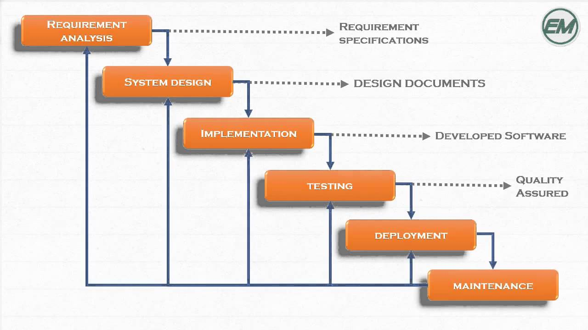

* **Why We Choose Waterfall Model?**

* We are choosing waterfall model, because in our system requirement are clear and well understood.

* Our functionalities are not going to be changed in long-term future as we are not adding any other module.

* It’s simple approach as it requires documentation at end of each phase and it’s very useful for us to verify it.

* Our system is an intermediate between the student and Subject experts so our services are clear.

1. **ANALYSIS**

**3.1 System Flow Diagram**

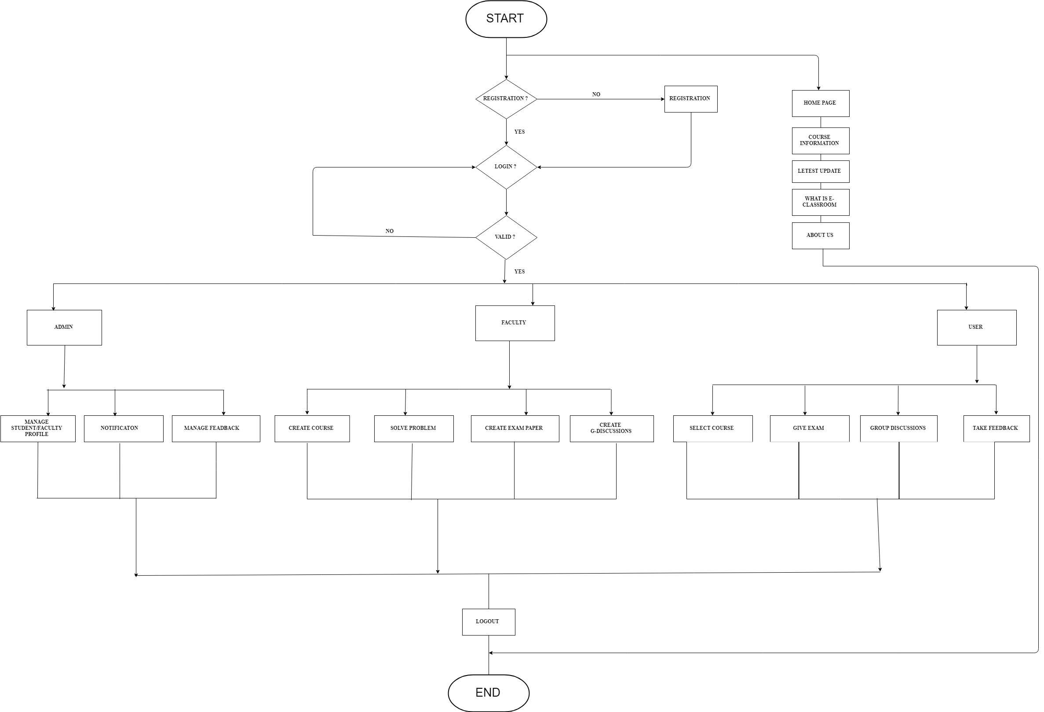

**3.2 Data Flow Diagram**

**3.2.1 CONTEXT LEVEL DIAGRAM**

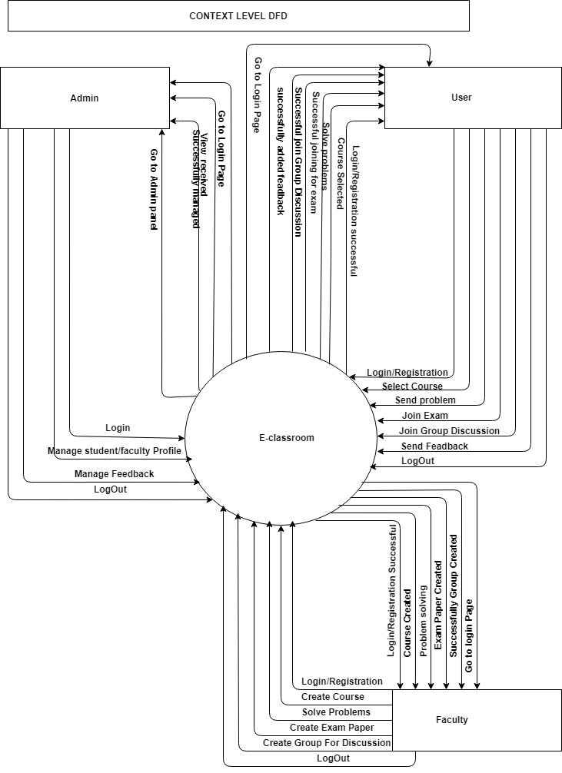

**1.2.2 FIRST LEVEL DIAGRAM**

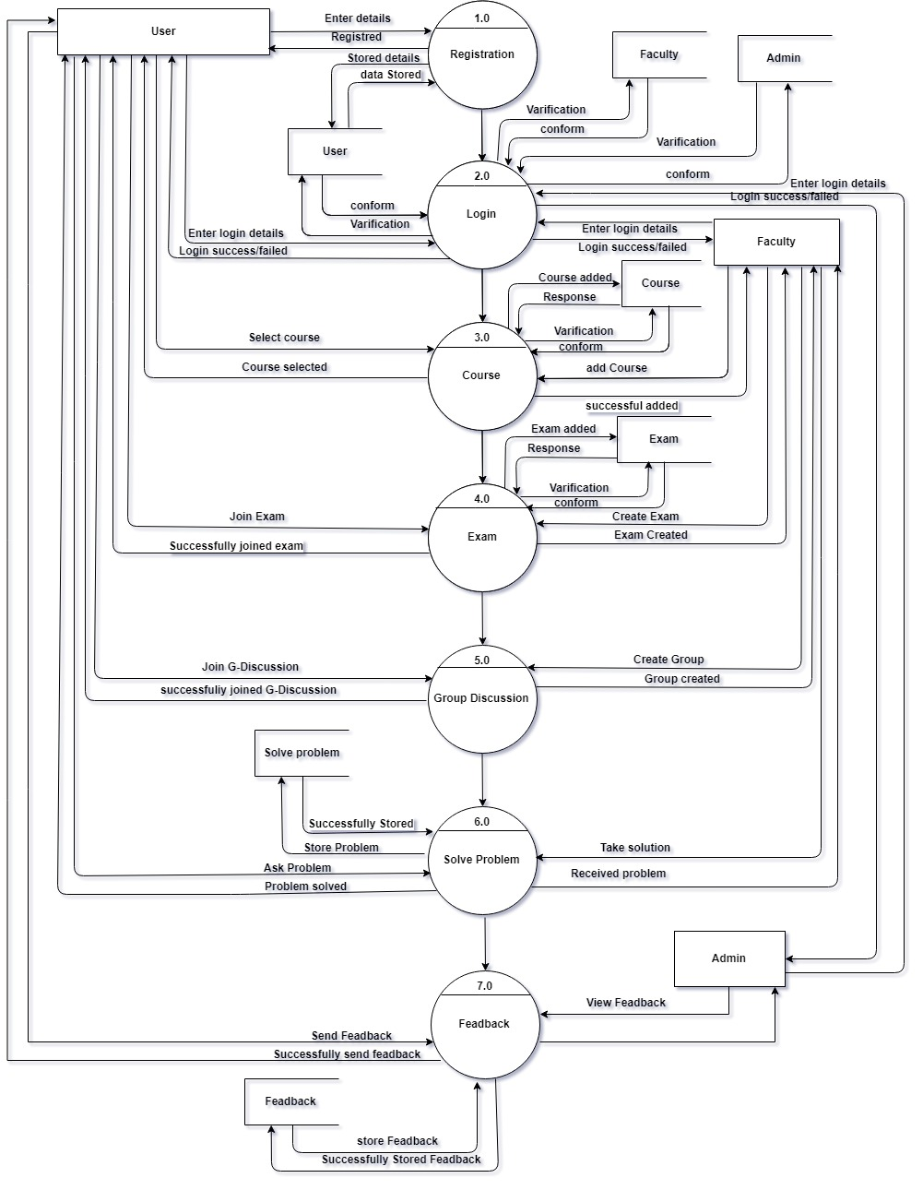

**3.3. ER Diagram**

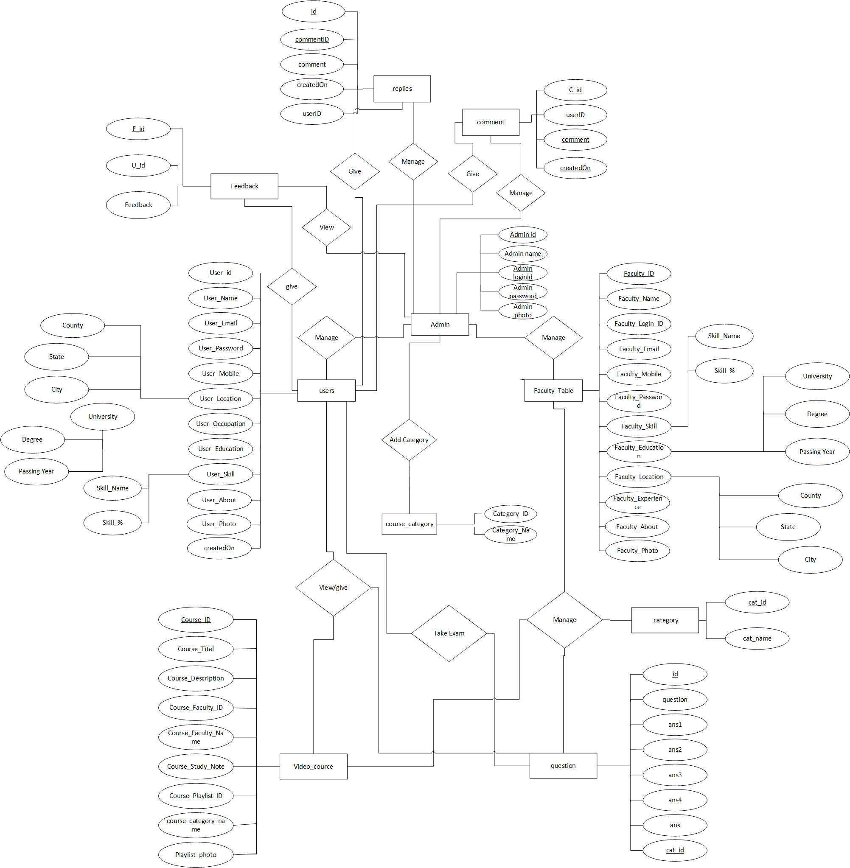

**4.DESIGN**

**4.1 DATA DICTIONARY**

Admin Table:

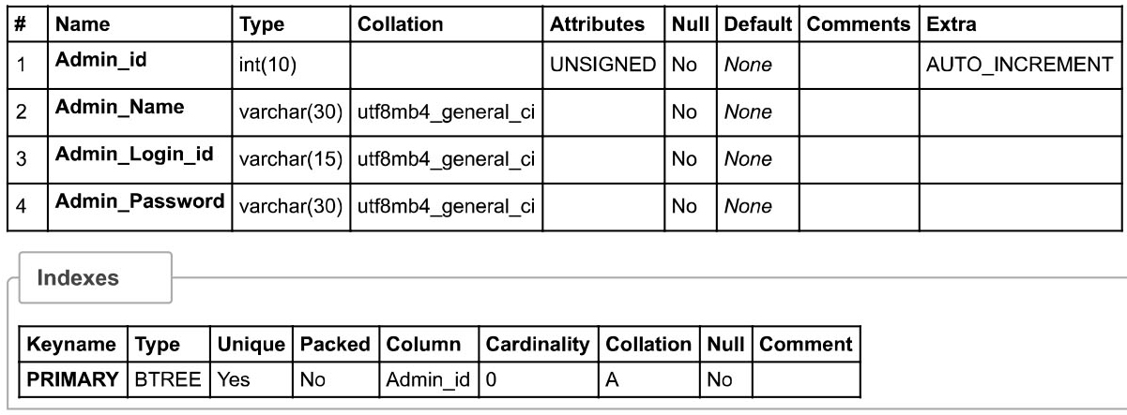

Comment Table:

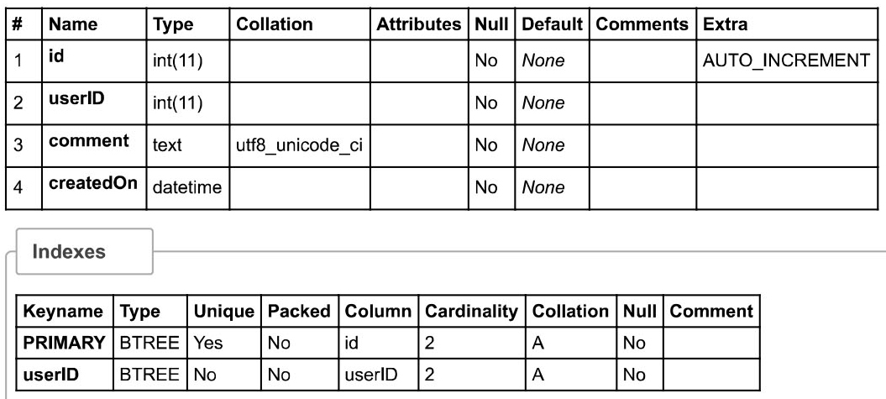

Category Table:

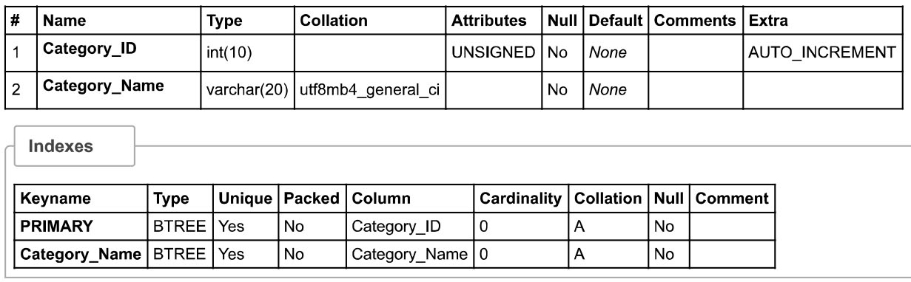

Exam Category Table:

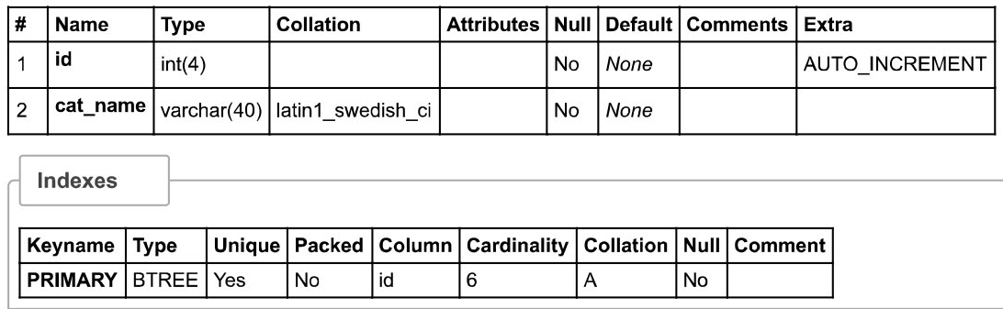

Faculty Table:

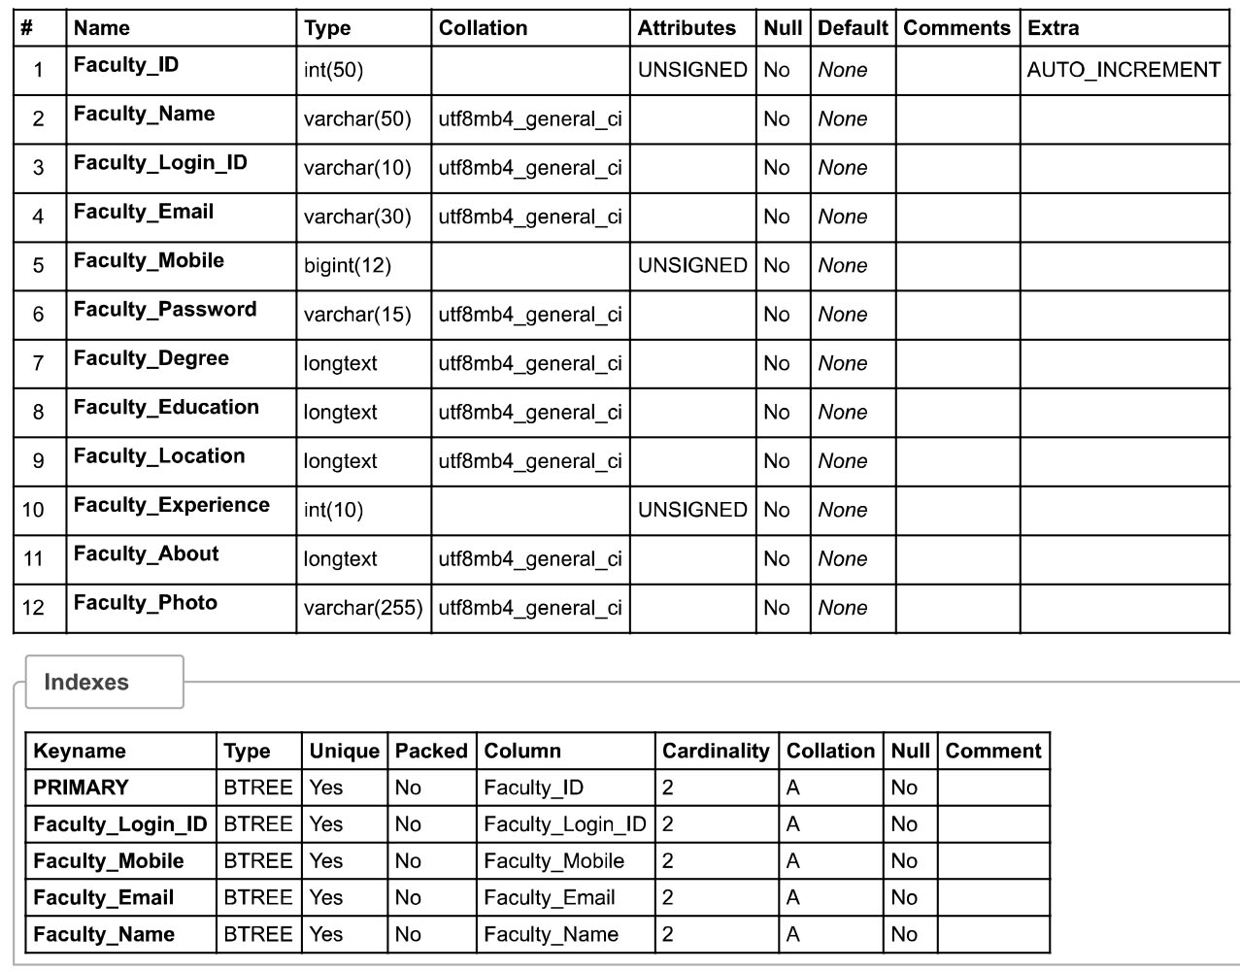

Feedback Table:

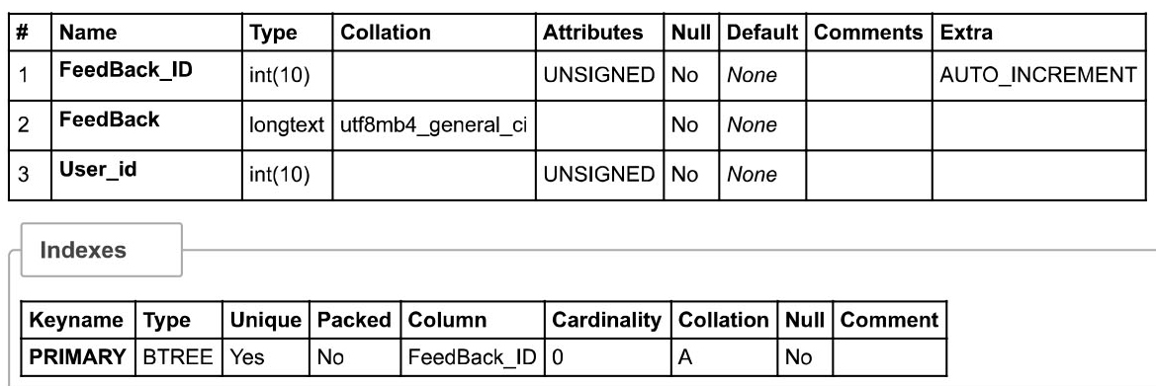

User Table:

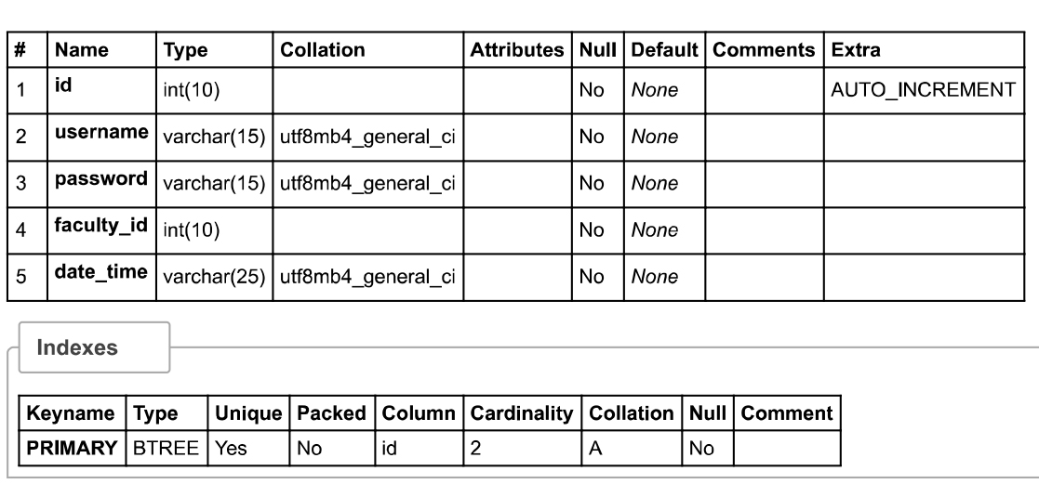

Problem Solve Table:

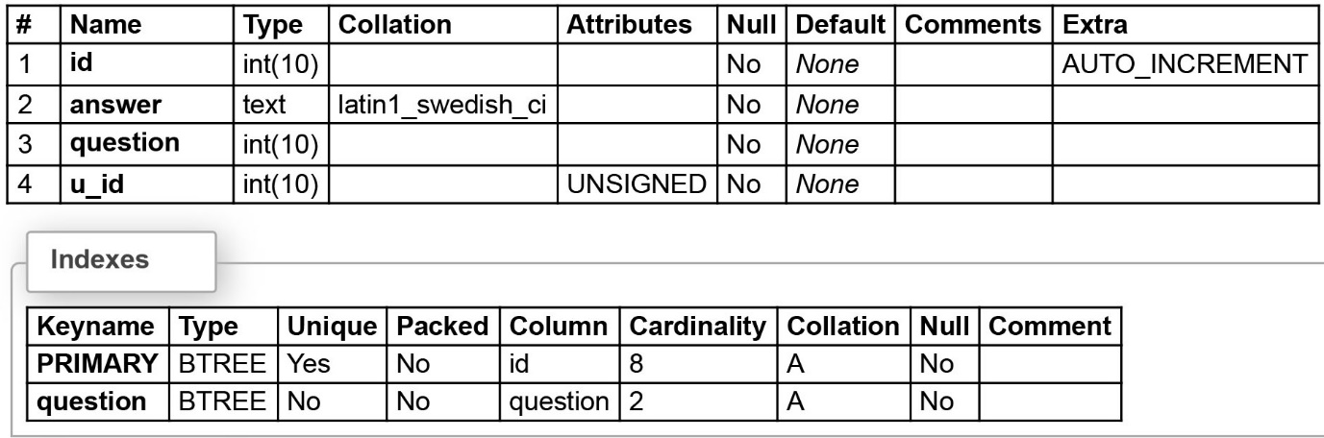

Comment Table:

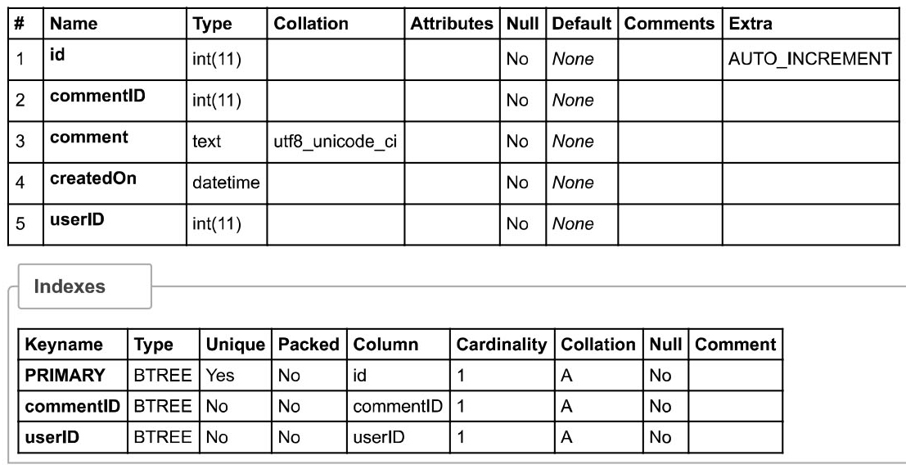

User Table:

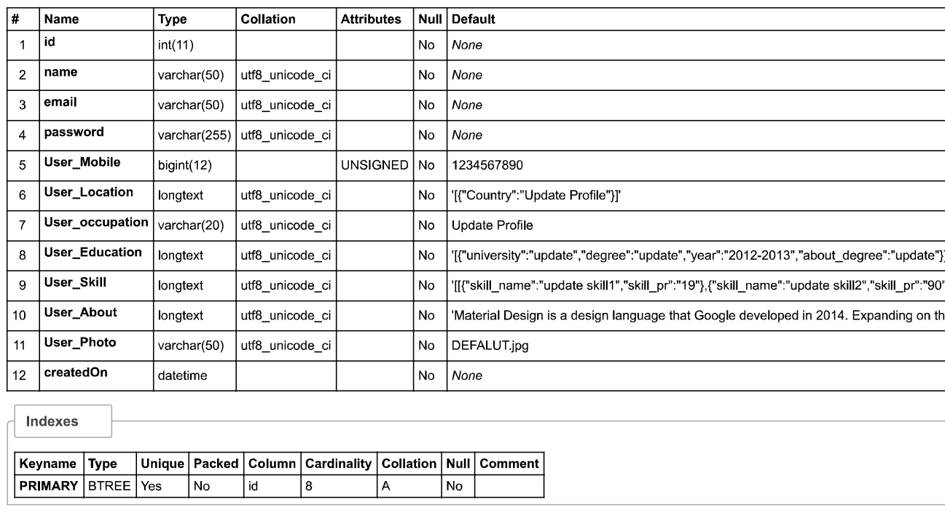

Course Table:

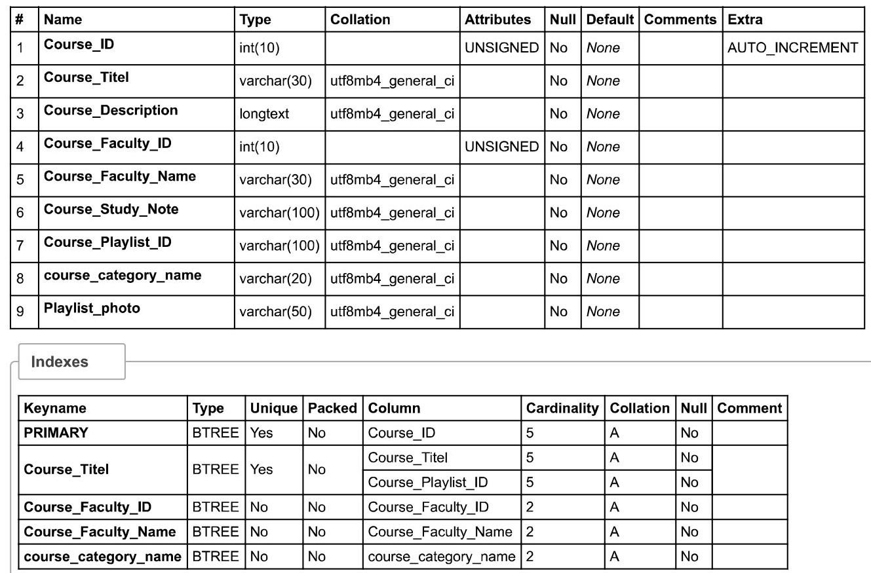

**4.2** **SCREENSHOTS**

**Home Page:**

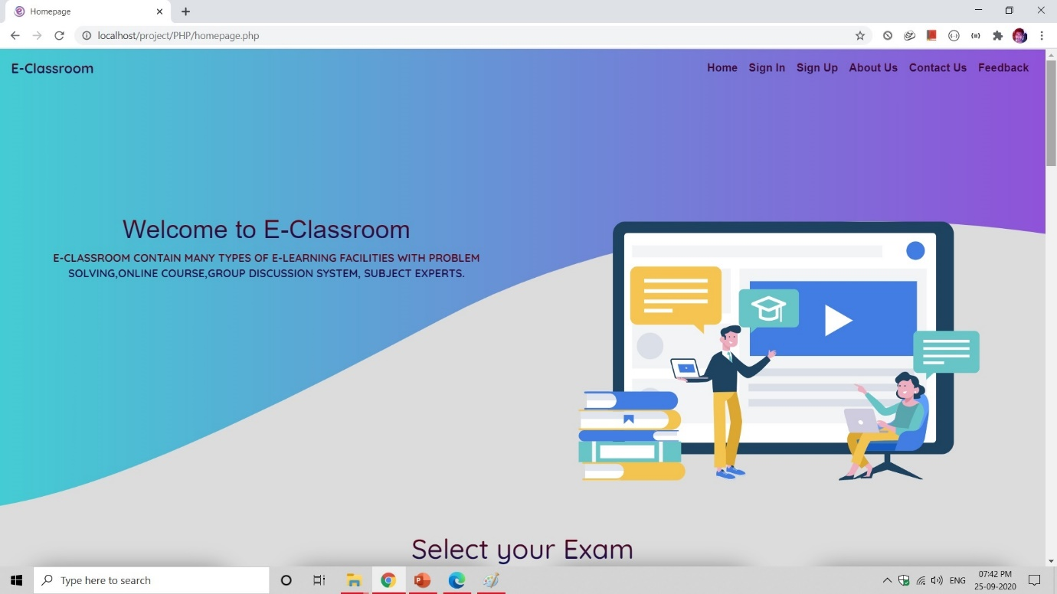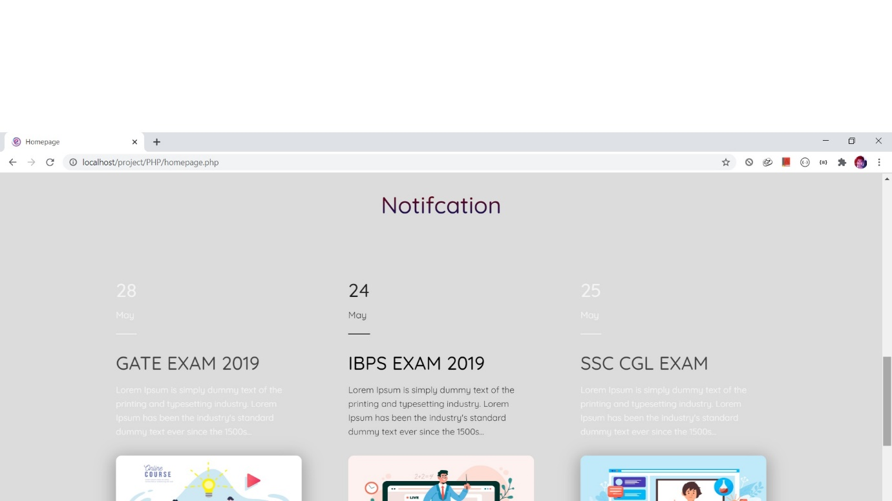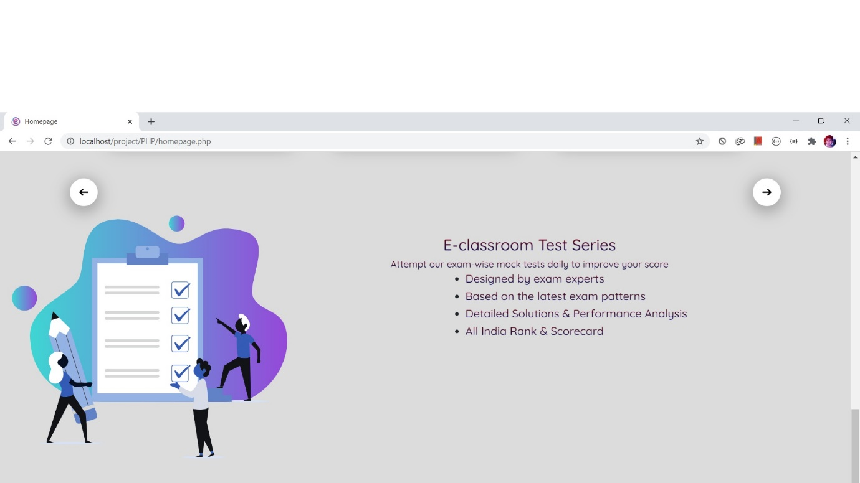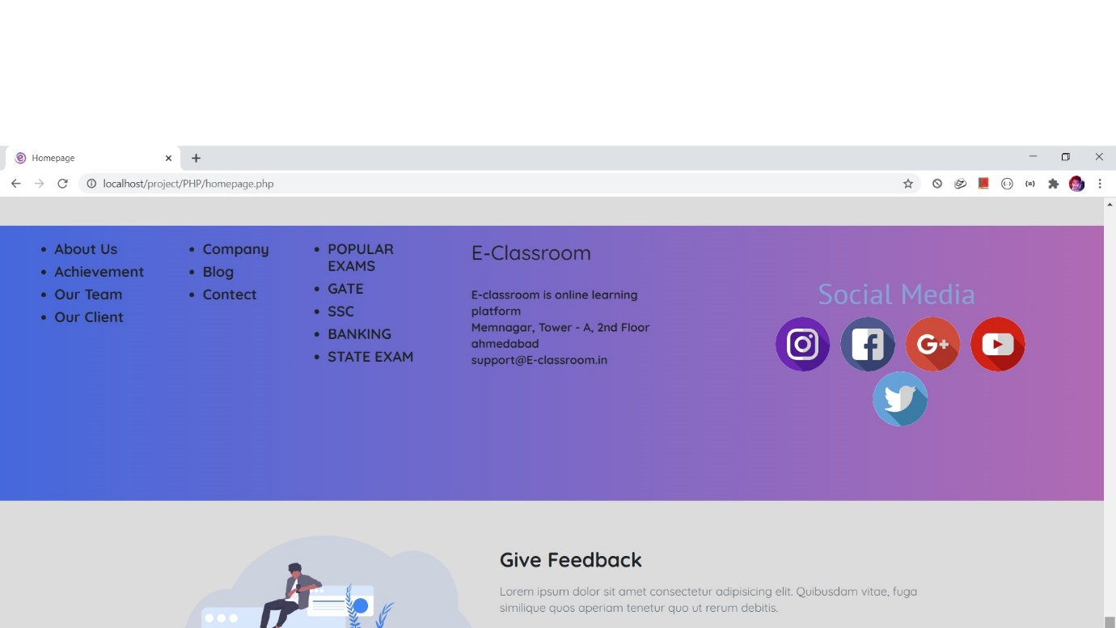

User login:

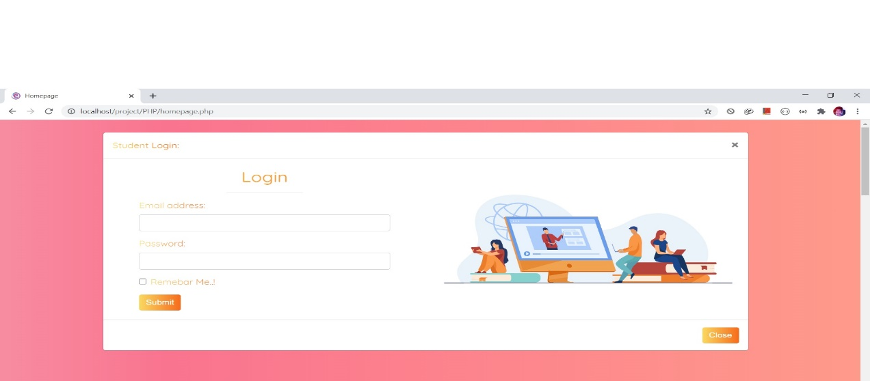

User registration

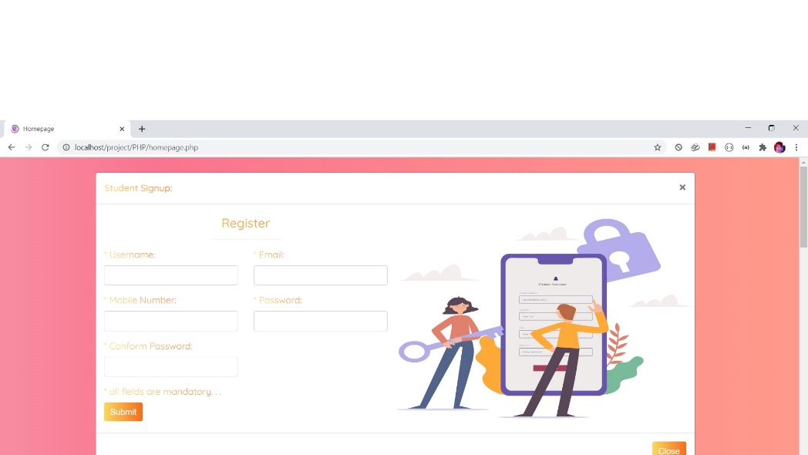

User profile

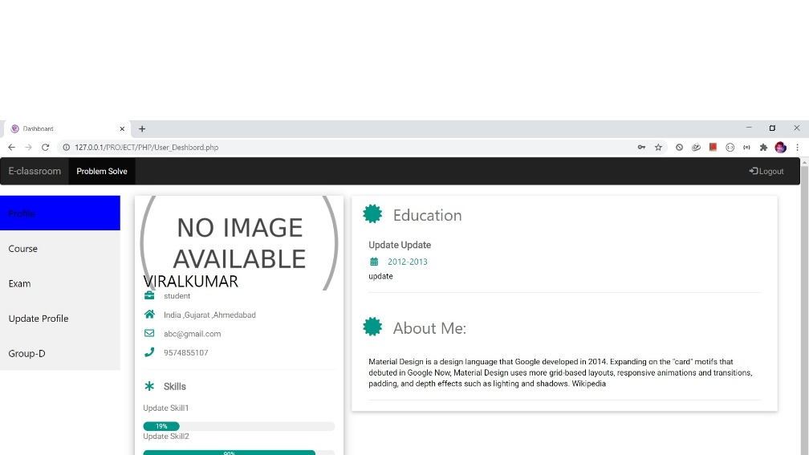

Course

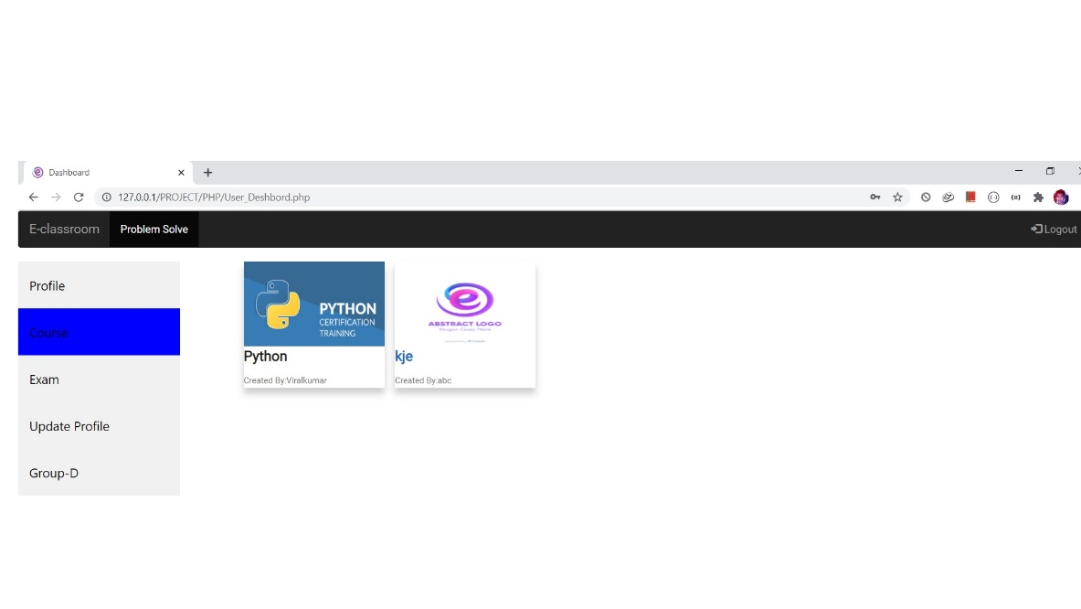

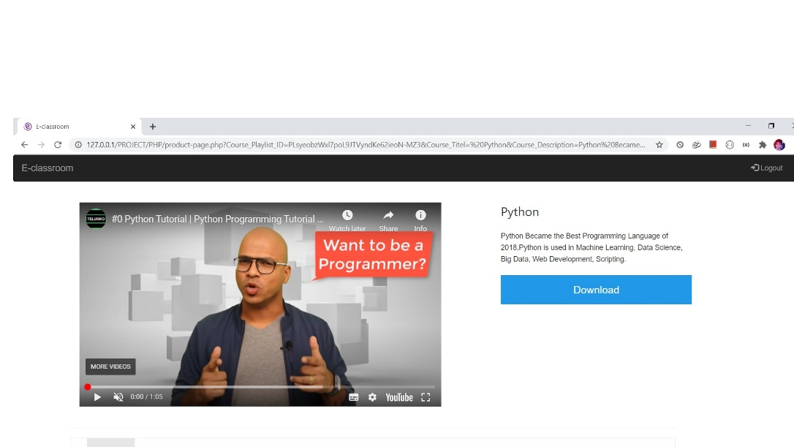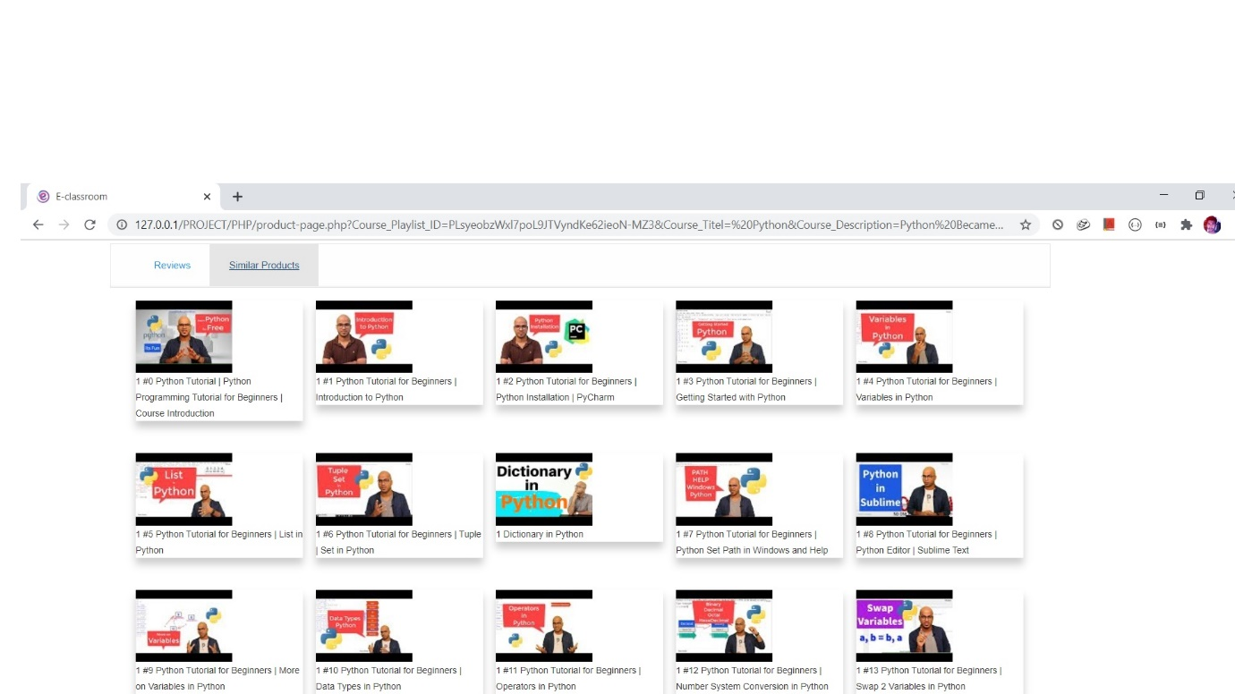

Exam

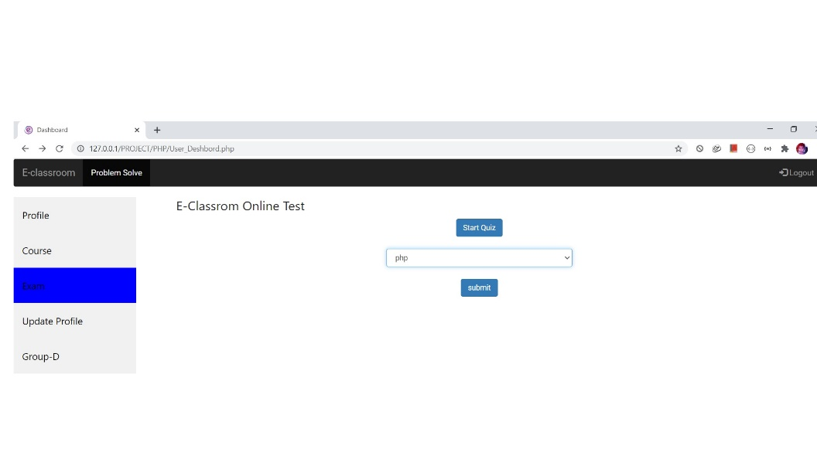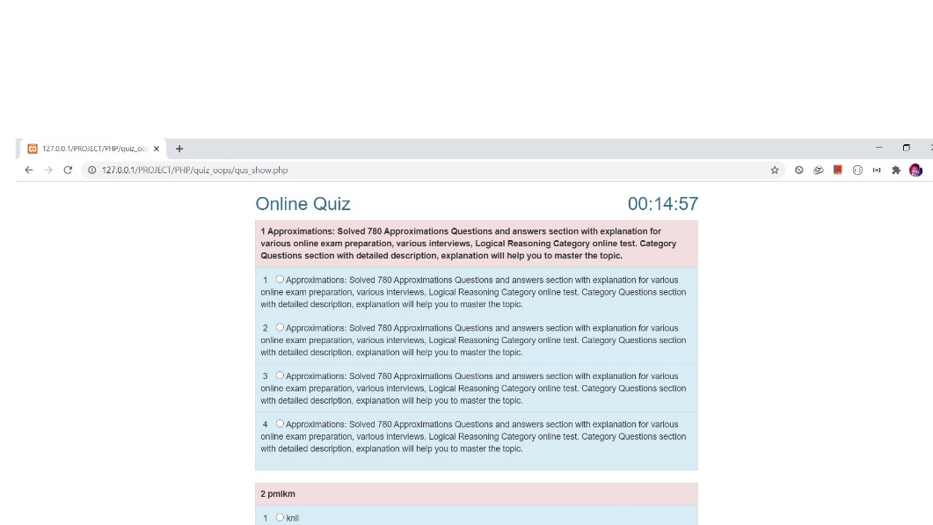

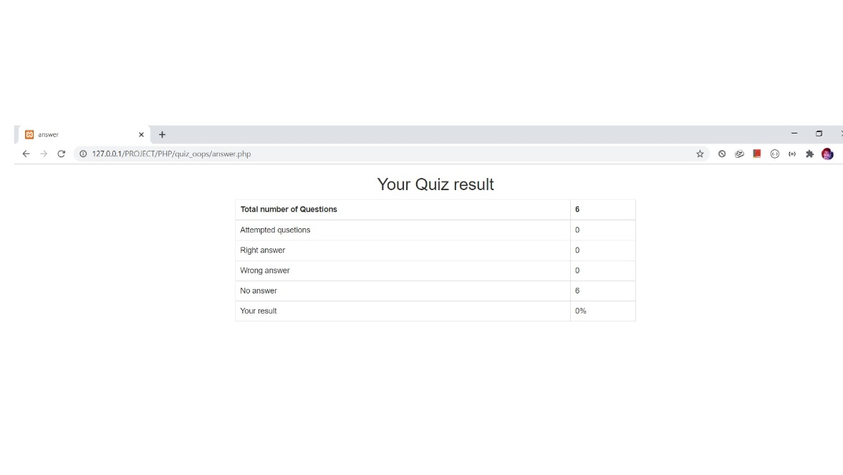

Update Profile

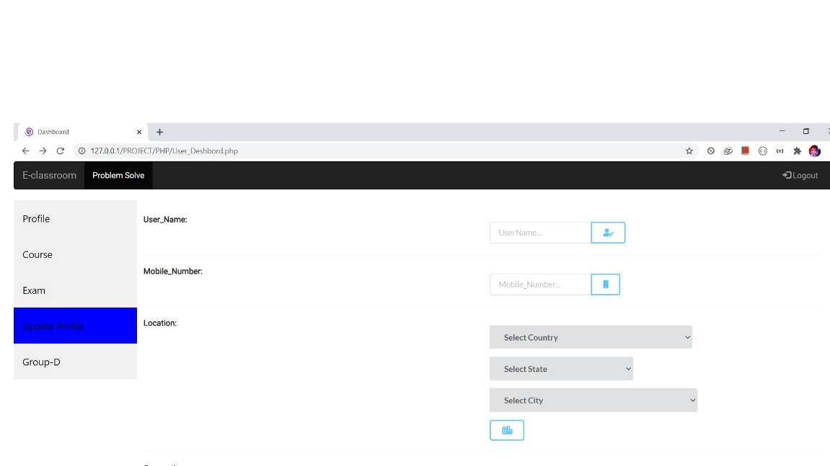

Problem Solve

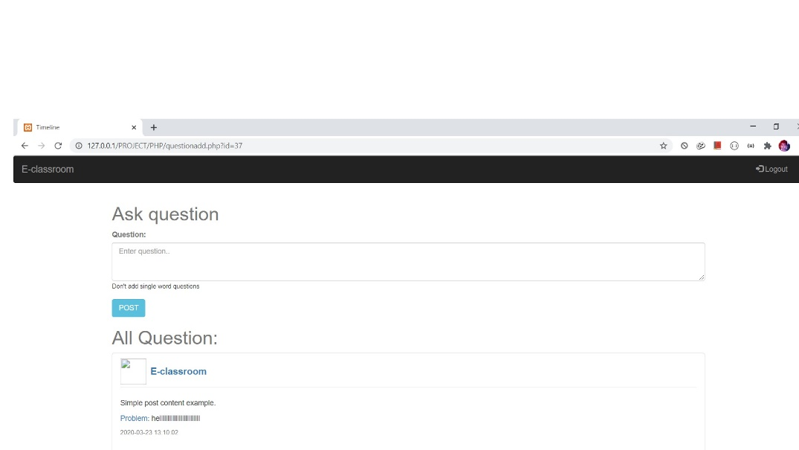

Faculty Login

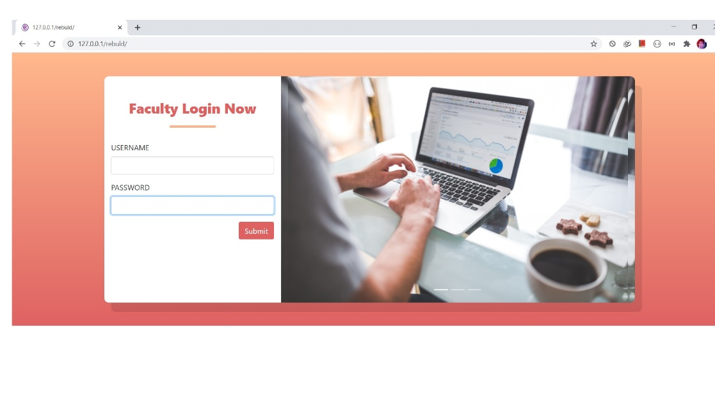

Faculty profile

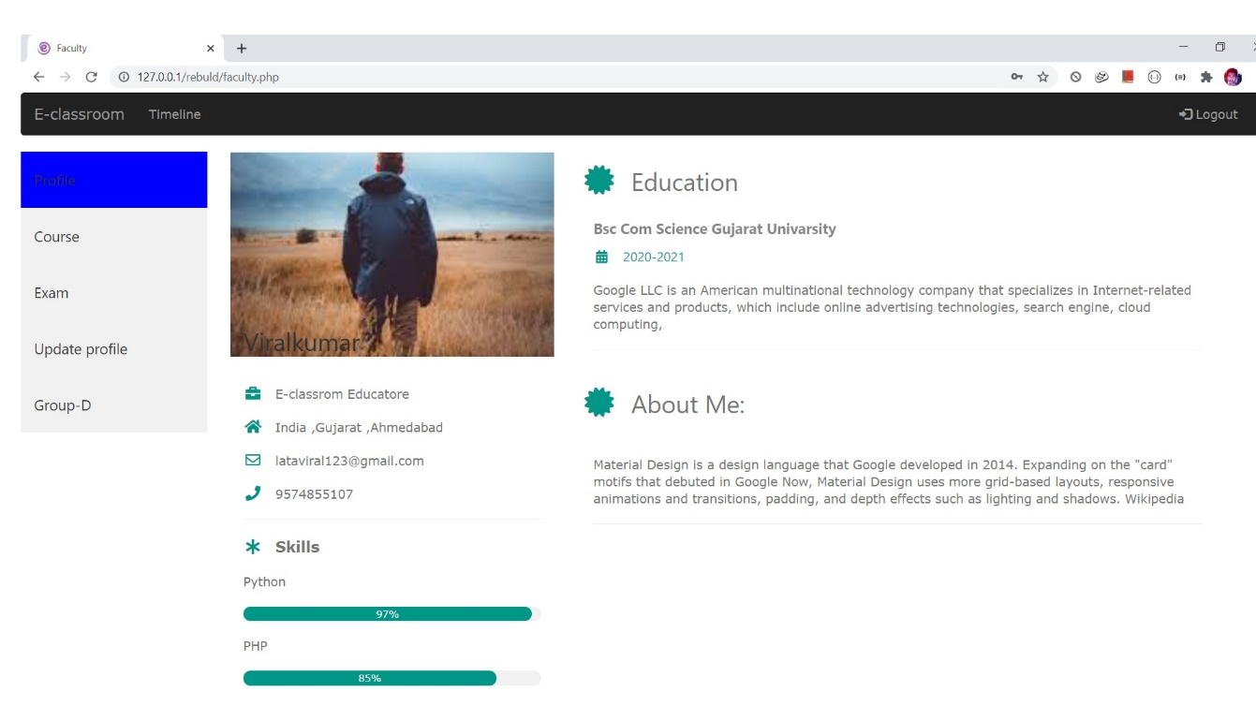

Add Course

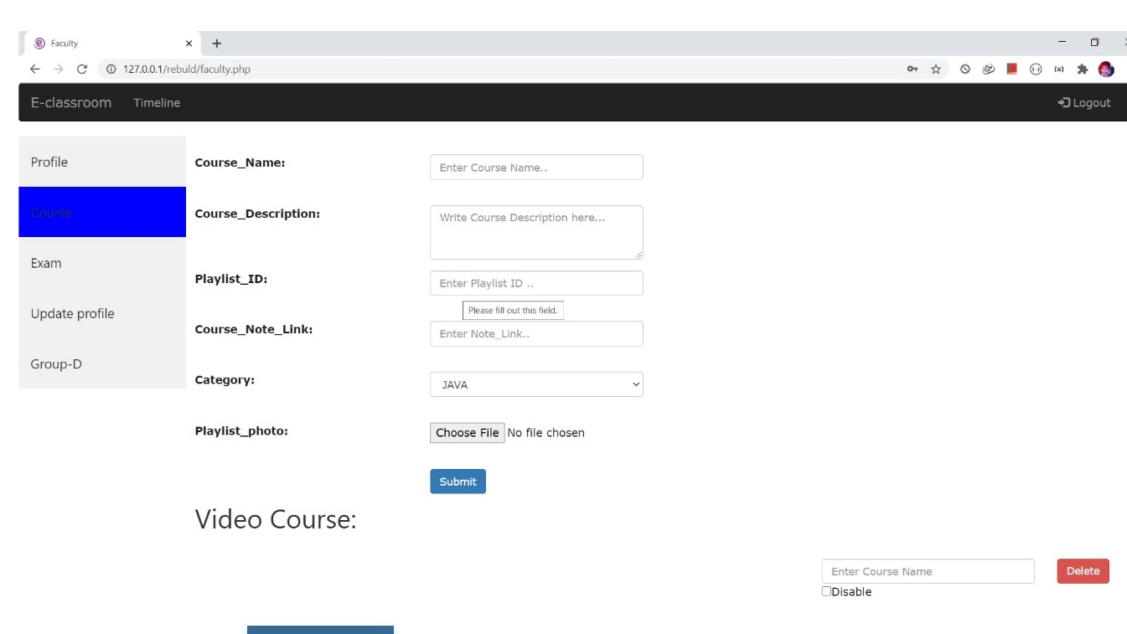

Add Exam

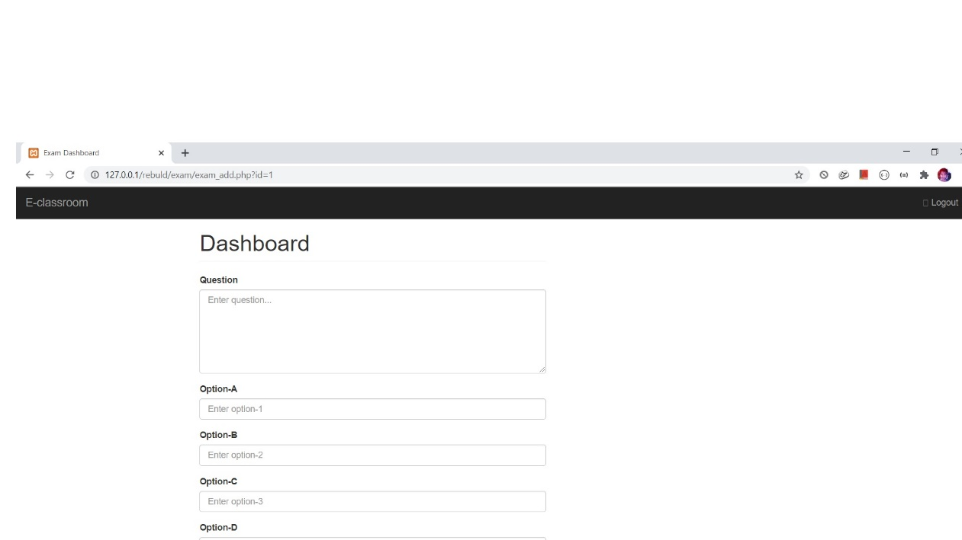

Create Group

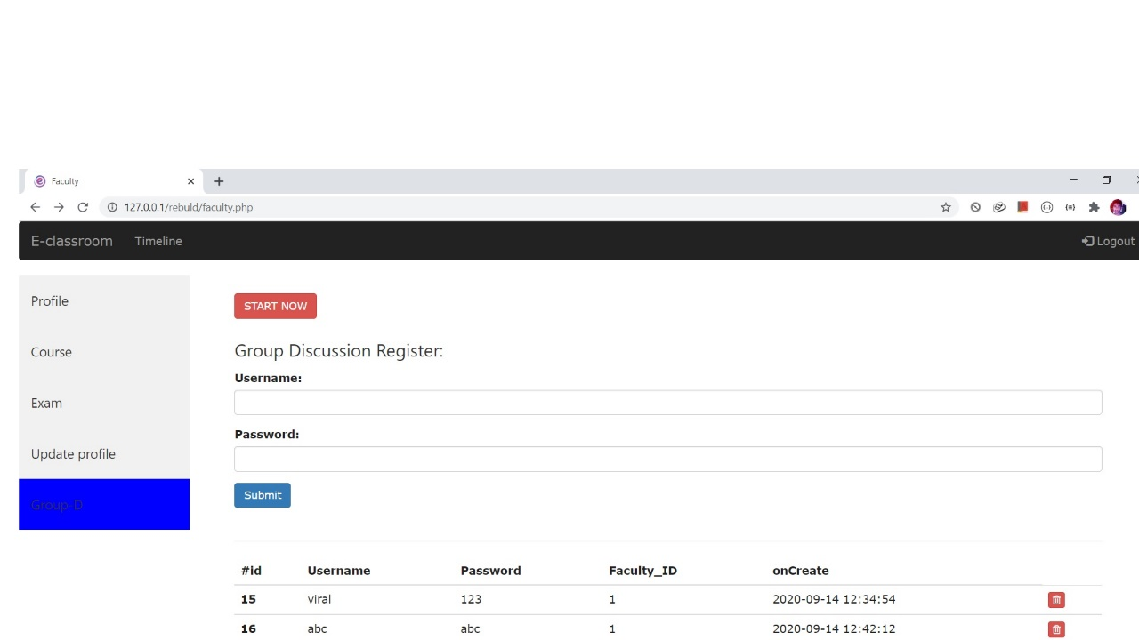

Admin Login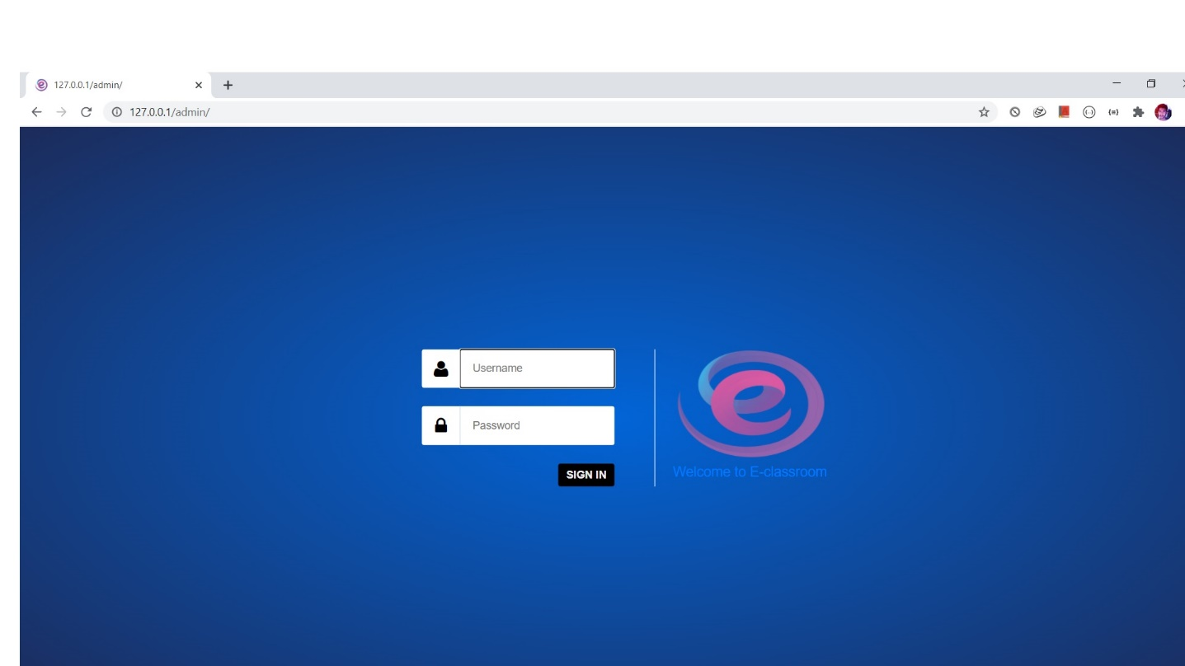

Manage User

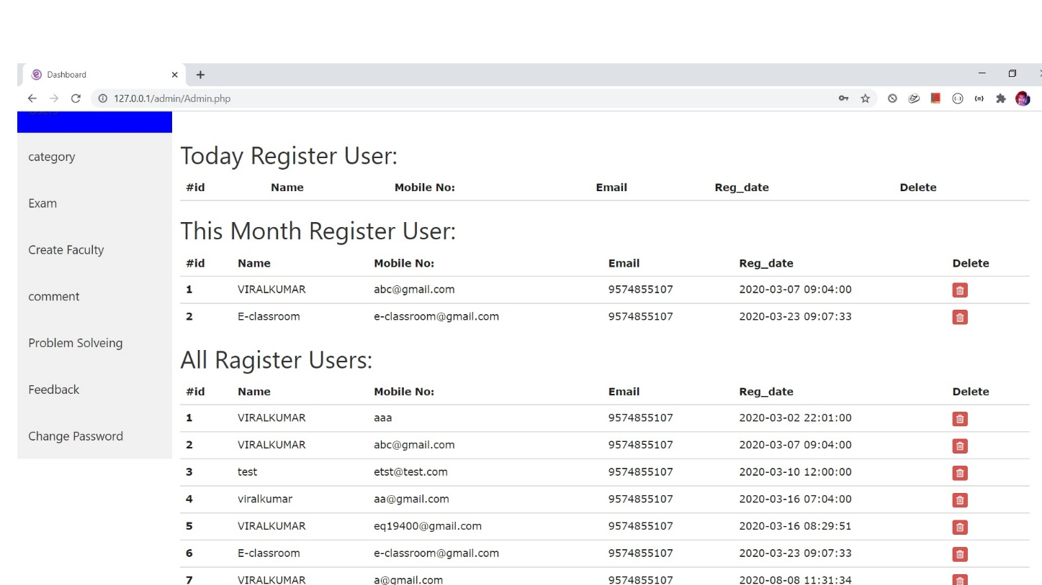

Course Category

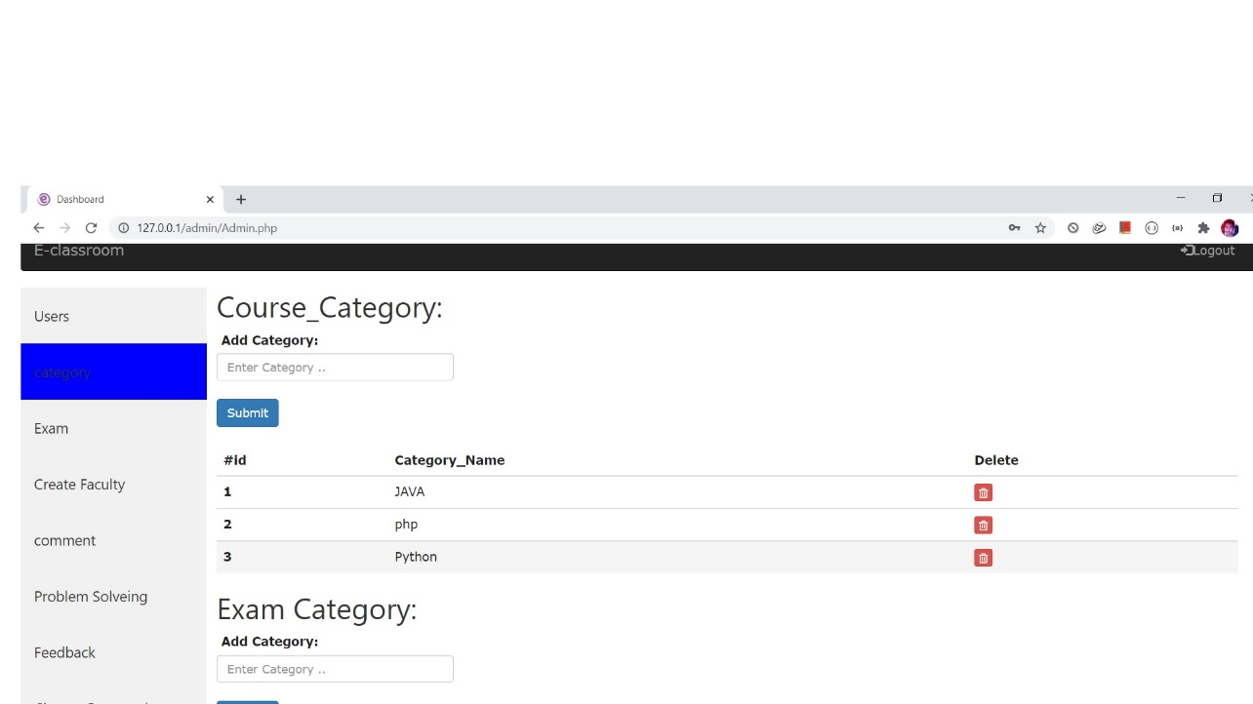

Add Faculty

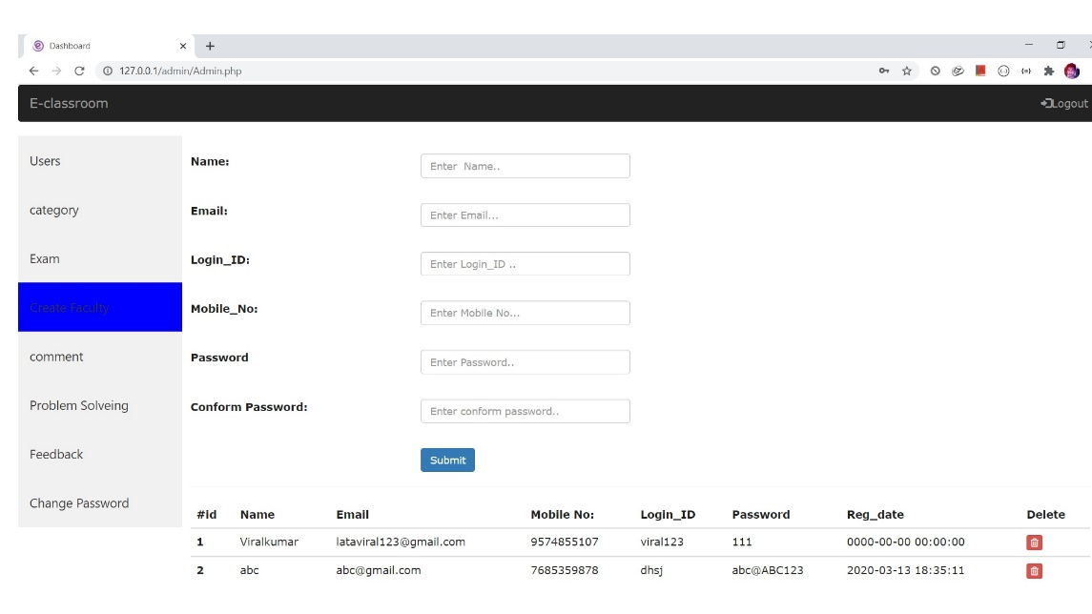

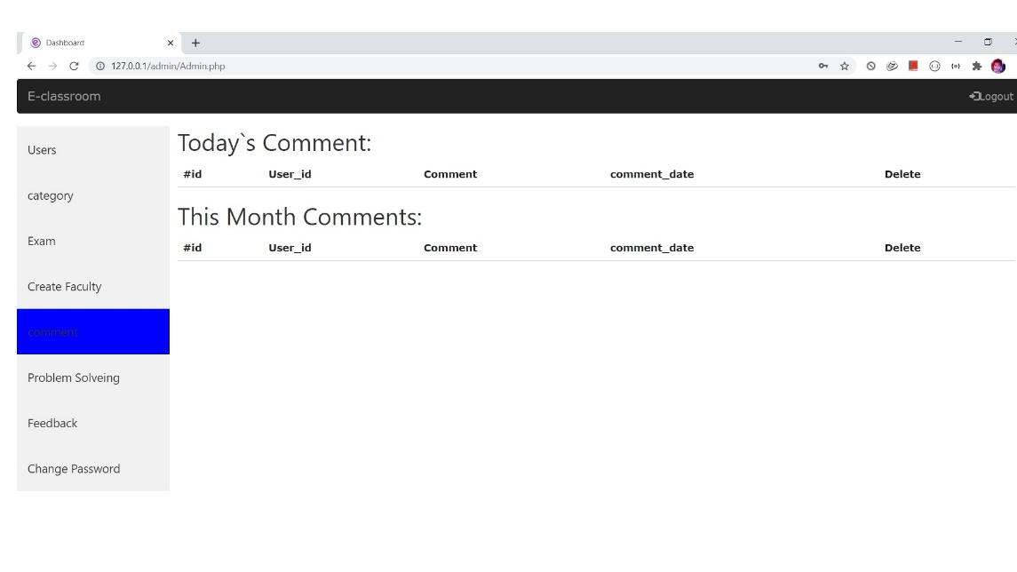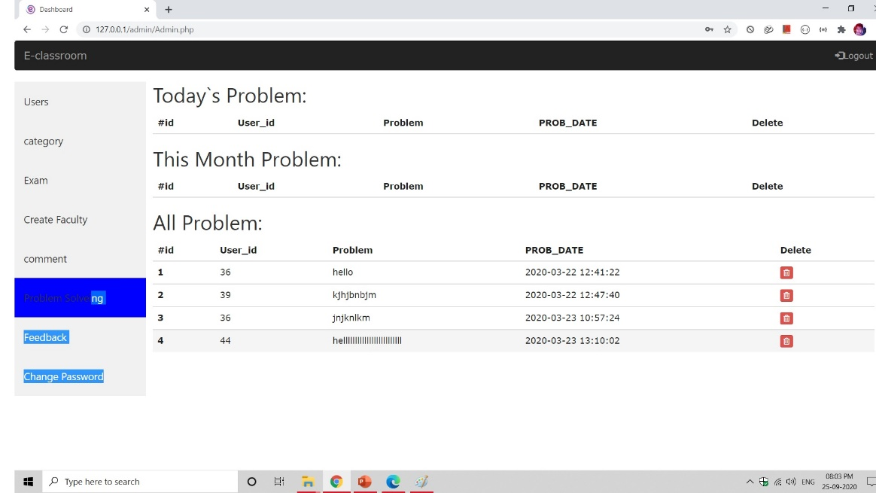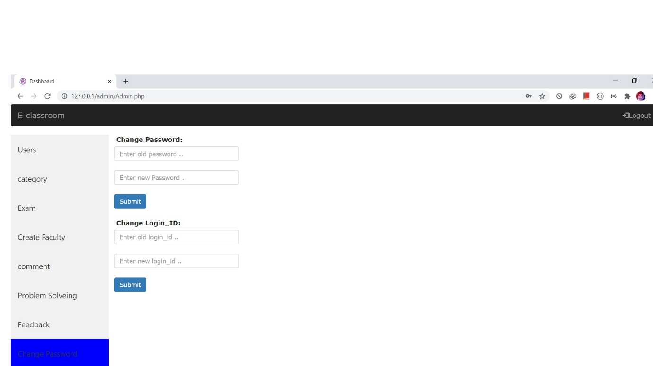

Group Discursion

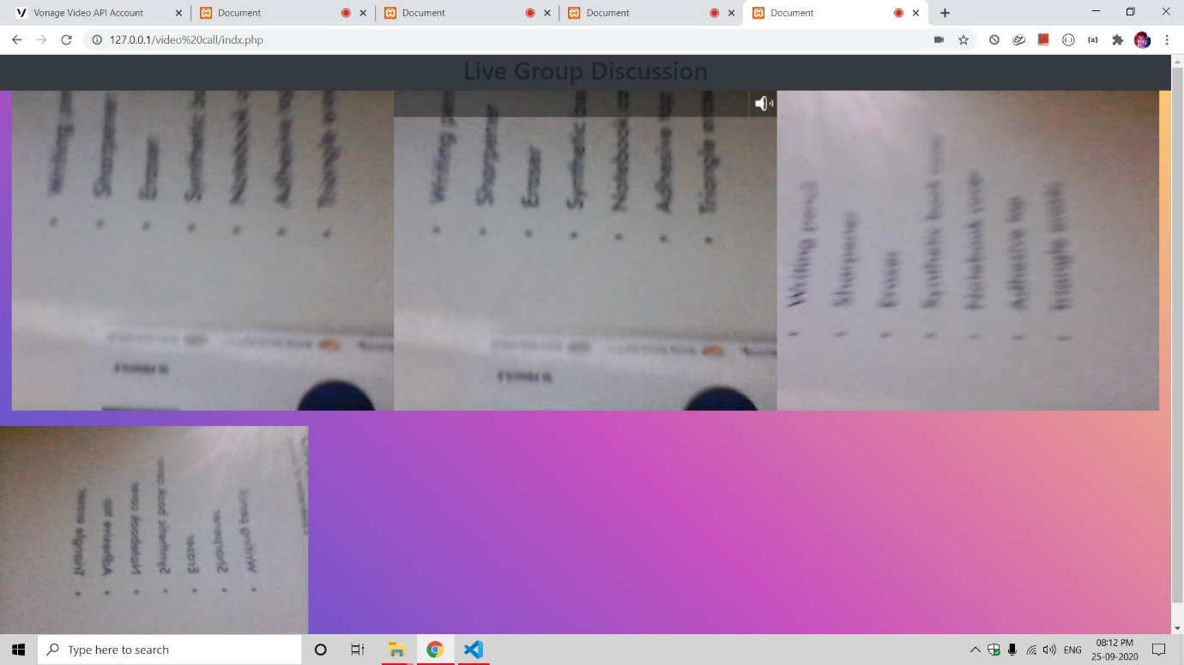

Feedback

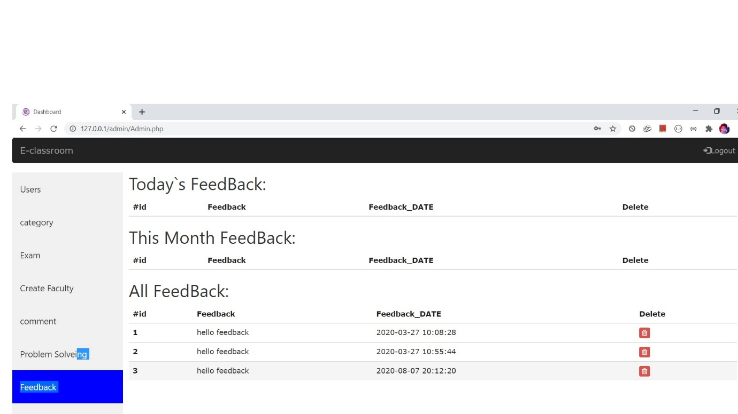

5.TESTING

5.1 Test Cases

|  |  |  |  |  |  |  |
| --- | --- | --- | --- | --- | --- | --- |
| **Test Case** | **Test Case Description** | **Test Case**  **Input** | **Test Data** | **Post Condition** | **Expected Output** | **Actual Result** |
| **1** | Verify the login Functionality of E-Classroom login Page. | Enter Valid Username & Valid Password. | [Username:n@gmail.com](mailto:n@gmail.com) Password:12345678 | User Should be view the ngo list page | Successful login | valid |
| **2** | Verify the login Functionality of E-Classroom Login Page. | Enter Valid Username & Invalid Password. | [Username:n@gmail.com](mailto:n@gmail.com) Password:123456@8 | Error message “Invalid username & password” | Popup is generated to display an error:” Invalid username & password” | invalid |
| **3** | Verify the login Functionality of E-Classroom login Page. | Enter Invalid Username & Valid Password. | Username:n@gmail!com Password:12345678 | Error message “Invalid username & password” | Popup is generated to display an error:” Invalid username & password” | invalid |
| **4** | Verify the login Functionality of E-Classroom   Login Page. | Enter Invalid Username & Invalid Password. | Username:n@gmail!com Password:123#5678 | Error message “Invalid username & password” | Popup is generated to display an error:” Invalid username & password” | invalid |

**6.CONCLUSION**

* The "E-classroom" has been developed by me and by my project partner by surveying various platforms and with the help of internal faculties and from the knowledge that we have.
* We developed this system for saving time & saving money.

7. **FUTURE ENHANCEMENT**

**8. ABBREVIATIONS**

|  |  |  |
| --- | --- | --- |
| **Sr. No** | **Abbreviations** | **Full-Form** |
| 1 | DFD | Data Flow Diagram |
| 2. | SRS | System Requirement Specification |
| 3. | ERD | Entity Relationship Diagram |
| 4. | RAM | Random Access Memory |
| 5. | GUI | Graphical User Interface |
| 6. | ADMIN | Administrator |

**9.BIBILIOGRAPHY**

**Websites**

* <https://unacademy.com/>
* <https://gradeup.co/>
* <https://byjus.com/>
* [https://www.udemy.com](https://www.udemy.com/)